 

**Placement Empowerment Program**

***Cloud Computing and DevOps Centre***

**DAY 9 TASK**:

Host a Static Website on a Cloud VM Install Apache on your cloud VM and host a simple HTML website

Name: SHAHANA.M.S Department: ADS



**Introduction**

Hosting a static website on a cloud Virtual Machine (VM) is a fundamental step in cloud computing and web hosting. By setting up a cloud VM and installing a web server like Apache, users can serve static HTML, CSS, and JavaScript files to the internet. This method is useful for personal portfolios, documentation, or simple landing pages without requiring complex backend services.

**Objective**

* To set up a Virtual Machine (VM) on a cloud platform (AWS, Azure, or GCP).
* To install and configure the Apache web server.
* To deploy and host a simple static website on the VM.
* To ensure public access to the hosted website.

**Importance**

* **Hands-on Cloud Experience**: Provides practical exposure to cloud computing and virtual machines.
* **Custom Web Hosting**: Unlike GitHub Pages, hosting on a VM allows greater control over server configurations.
* **Scalability & Flexibility**: Cloud VMs can be scaled based on traffic and workload.
* **Real-World Application**: Used by businesses and developers for hosting websites efficiently.

**STEP-BY-STEP OVERVIEW:**

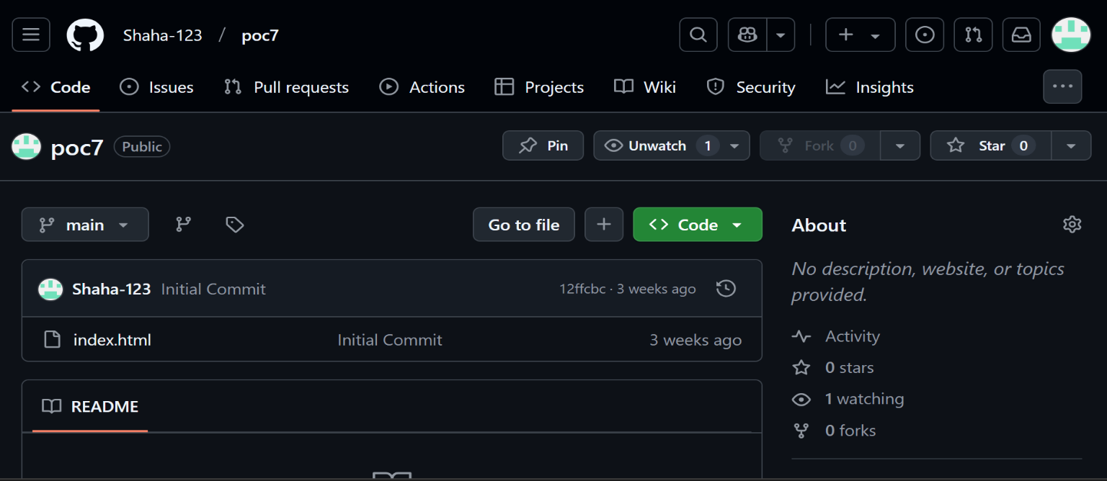 Step 1: Just have a html file in your git repository .

.

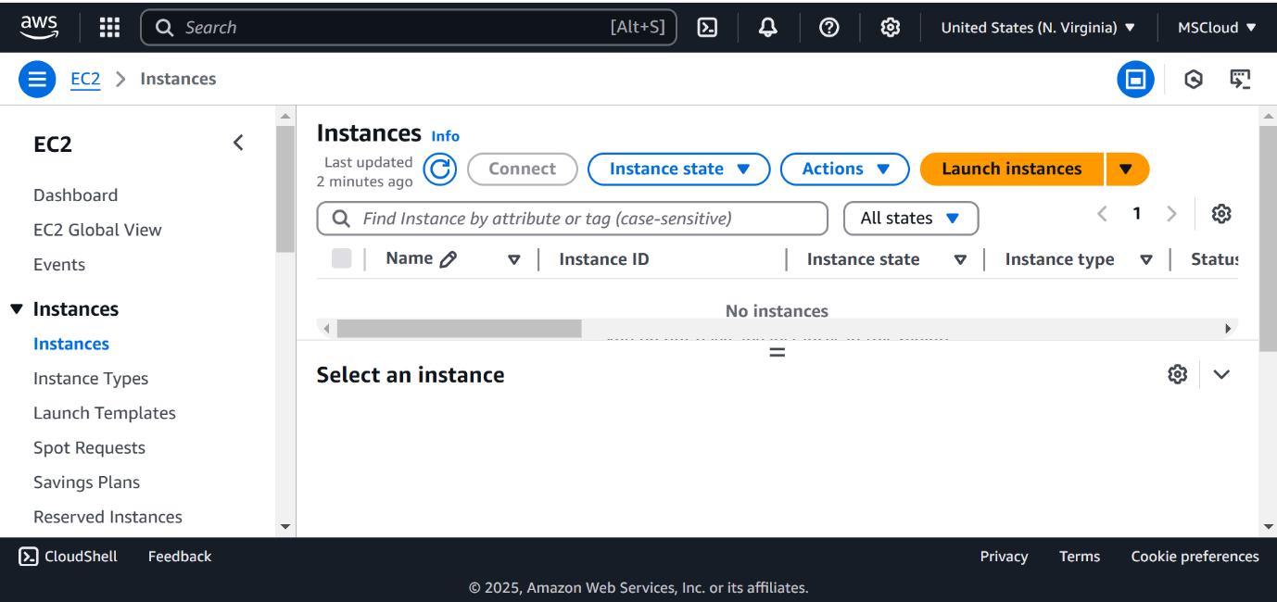Step 2: Launch an EC2 instance, select Ubuntu as the OS , create a key pair (e.g., key.pem), and select the created instance and connect and then go to SSN client to copy the SSN code that you have which is useful for next steps.

Step 4: Open PowerShell, navigate to the 'Downloads' directory by changing the directory as cd Downloads command.

Now just copy and paste the command you have copied in SSN client



Step 5: Run the command sudo apt update to update the package list.



Step 6: Run the command sudo apt upgrade, and press 'Y' is like an yes to give acces to proceed the process.



Step 8: Install the Apache server by running the command sudo apt install apache2, and press 'Y' – access for installation



Step 9: Insert your files by running the command git clone to clone your repository containing the website files.

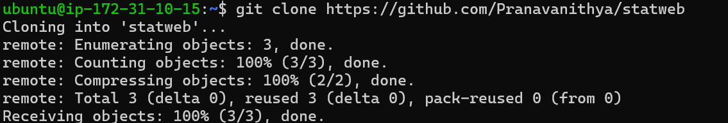

Step 10: Run the command cd /var/www/html to navigate to the web server's root directory, then type ls to verify that your HTML files from the GitHub repository are present.

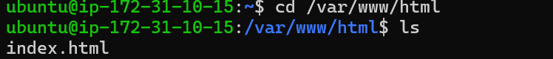

Step 11: Copy the Public IPv4 DNS from the instance details page in the EC2 console, as shown in the image below.

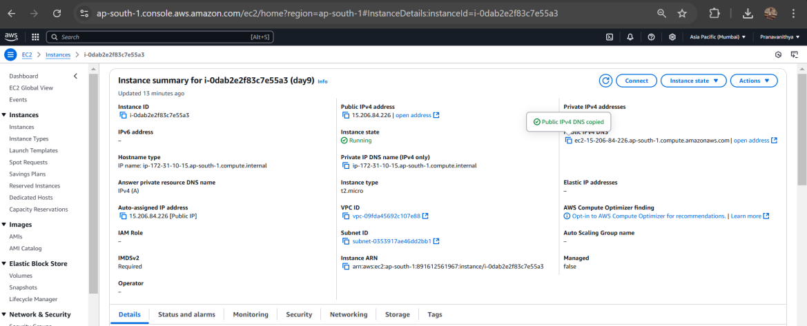

Step 12: Open Chrome and paste the copied Public IPv4 DNS in the address bar to view the content of your index.html file.

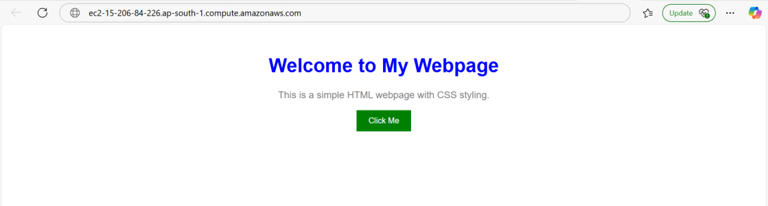

**Outcome**

* Successfully deploying a static website on a cloud-hosted VM.
* Understanding how to install and configure a web server.
* Learning how to manage a cloud-based web hosting environment.

Gaining knowledge of networking, security settings, and domain configuration for hosting